(Approx. 1,619 words)

From Rubber Boots to 38% of the Worldwide Cell Phone Market!
By Lou Torraca, President of the TUG (Computer User Group of the Hawaii MOAA Chapter)
www.the-tug.org
af06hi (at) gmail.com

This article has been obtained from APCUG with the author’s permission for publication by APCUG member groups; all other uses require the permission of the author (see e-mail address above).



From Rubber boots to 38% of the worldwide cellphone market!
Yup, that’s a true fact and the name you will immediately know is Nokia which began in the last part of the 19th century as a rubber goods manufacturer. If you’re really curious to know more, register and write a comment at the end of this column and I’ll tell you where to get “the rest of the story.”

As you can see, this is all about the Consumer Electronics show. Early numbers coming in on the event, which ran from Jan. 7 to 10 in Las Vegas, show that attendance was up year-over-year. CES attendance was calculated at more than 120,000, which was up from 98,495 for the first two days at the 2009 event.

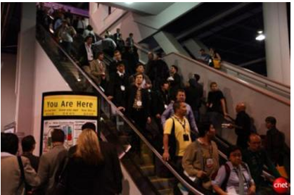

The event also attracted 330 new exhibitors. My feet are still recuperating from all the walking…the press gaggle begins on Tuesday, 2 days before the opening, with meetings and a couple press conferences and then the official CES press event, CES unveiled where a thousand or so press and bloggers are invited to meet a hundred or so exhibitors showing off their “goodies” in the Venetian Ballroom. Then an all-day marathon of press conferences followed by the evening Digital Experience in the Mirage Ballroom where another hundred or so do a similar thing. On Thursday the rush is on as the Show opens and it’s a challenge to not run out of steam before the evening Showstoppers at the Wynn, specially if you were invited to Lunch at Pieros an excellently planned and executed smaller, more exclusive version of the others. So, what follows is mostly a listing of just a few of the many things I was able to see and checkout. Many had not been priced yet and won’t be on the market for a month or two, but keep tuned, as I will continue next time with more as well as updates I may receive on these. You can also Google many of them for more info.

Samsung, Panasonic, LG, Sony and others all debuted 3-D-capable TVs this year, but at prices of $200 or more above other flat-screen sets, it's not certain whether customers will be buying. Besides, just think about all those glasses you’ll need for your Super Bowl bash!

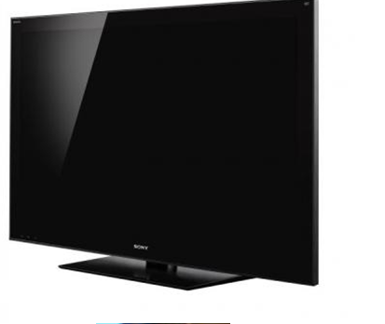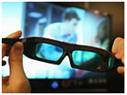

Microsoft Chief Executive Officer Steve Ballmer kicked off this year's keynote sessions with an upbeat take on how his company plans to not only extend its reach in the home entertainment market, but transform the sector as well.



"From the largest screen on the wall to the smallest screens in people's pockets, we are delivering the entertainment people want," Ballmer said.

The space allotted to games at this year's CE event nearly doubled from the previous year, to 13,000 square feet. This year's game-based innovations included a motion-control system from Microsoft dubbed Project Natal and a functioning guitar that can be used in "Rock Band" and "Guitar Hero”.

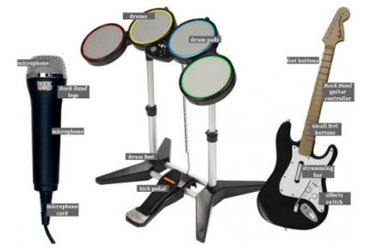

IMHO, The IdeaPad U1 Hybrid from Lenovo is arguably the coolest gadget at the Consumer Electronics Show.

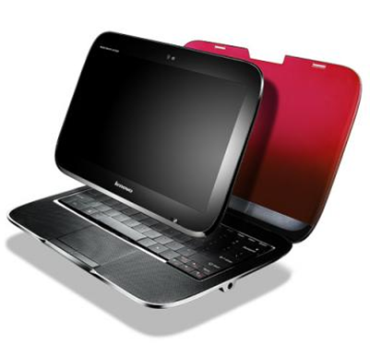

The IdeaPad U1 gives users both a laptop and a tablet in one. Here's how: When the screen and keyboard base are attached the computers works as a 3.8 pound Windows 7 laptop running on a CULV Intel Core 2 Duo processor. But when you detach the 11.6 inch HD screen, that portion becomes a 1.6 pound tablet running on Lenovo's Skylight linux operating system and a 1Ghz Snapdragon processor. It also has 3G embedded and 16GB of solid state memory. The two pieces can work independently because they both have battery power enough for five hours. The base can actually work without the screen as long as you connect it to another display. The two piece can also work in coordination.

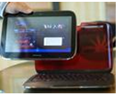

The base can share power with the tablet. Users can also begin a browsing session on the full laptop and continue it on the tablet. Users will have to get used to Skylight, which is more akin to the iPhone's app based operating system. And I'm still curious how sturdy the device will be when you keep attaching and detaching the parts. But this is one cool device that makes a lot of sense and lets you enjoy the perks of a tablet while still having the full keyboard and power of a laptop. The Lenovo IdeaPad U1 hybrid notebook will be available June 1 with an estimated retail price of $999.

On the other hand, for sheer classy looks and price, the NX90Jq notebook sports not one, but two touchpads, one on each side, which should be music to any armchair DJ's ears. This is a home entertainment center-piece both in looks and specifications.

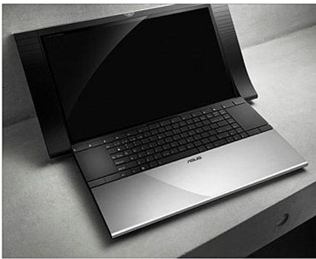

The NX90 has an Intel Core i7 CPU (either 7200QM or 8200QM), an 18-inch 1080p display, an Nvidia GeForce GT 335M graphics card, dual hard drives, and a Blu-ray drive. That config will run you $2,499.The Asus NX90 will start at $1,999, and be available sometime in the second quarter of 2010.

My favorite software just keeps getting better all the time! The End of Fragmentation: New Diskeeper 2010 is the only product available today that actually prevents fragmentation before it happens. Utilizing a new revolutionary technology called IntelliWrite™.


2010 benefits:

•Prevents up to 85% of all fragmentation before it can happen
•Operates invisibly without active resource conflicts.
•Boosts read/write speeds above previous limits
•eliminates slow boot-up/patches/downloads
•Significantly reduces power consumption
•Increases productive life of servers, workstations and laptops
•eliminates the need for defrag schedules or "wake up" times
•Cuts back “reactive administration” and Help Desk traffic
•Lowers cost of ownership and has fast return on investment.
The race to be number one in the emerging e-reader device market space is a crowded field as evidenced by product demos and displays during CES. Both tenured vendors, such as Sony, and startups, such as Copia, are developing devices with new features, improved user interfaces and a slew of accessories to meet what they hope will be a robust consumer market.

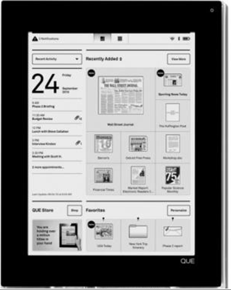

The PlasticLogic QUE was one of the most anticipated product launches of CES 2010. A lot of information had been revealed or leaked beforehand, but most of us tended to think of the QUE as an ereader oriented toward newspapers and magazines and aimed at business professionals. The reality exceeded those expectations as the QUE proReader turned out to be what PlasticLogic CEO Richard Archuleta called a “wireless briefcase.” Not only does the QUE have deals in place with all of the top business periodicals, but it also syncs with Microsoft Exchange, provides “print-to-device” functionality, reads Microsoft Office documents and PDFs, and allows BlackBerry users to transfer data from their smartphones. Unfortunately, there was another way in which the QUE exceeded expectations: the price. The two models cost $650 and $800. At that price, it will have to compete with tablet and slate computers.

Amazing what a small projector can do. Compact, lightweight and super mobile, the MPro110 pocket-sized microprojector opens up a whole new world of opportunity for people wanting to present or share digital content on-the-move.

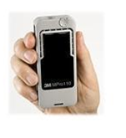
The MPro110 MicroProjector is an LED-driven device that offers full VGA resolution connectivity to a range of multimedia devices. Being a 'pass-through' device, the projector requires an image source device to be connected.
Lenovo's dual screen laptop computer, W700ds is a large, $5,000 laptop that looks as if it swallowed a netbook. It has a 17-inch main screen, from which a second, 10-inch, netbook-sized screen slides out. Almost like magic {:-)

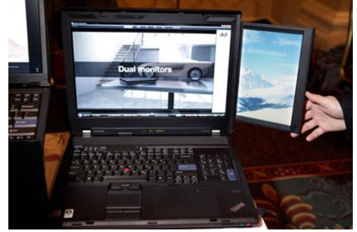

Why not recharge electronic gizmos while you carry them? BTW, this is NOT just for the ladies! The Concord Keystone 4U2ReUSE Solar Sling tote bag lets you. Made from 100-percent recycled plastic bottles, the Solar Sling features a flexible solar panel and a battery pack with USB connectors. It charges phones, cameras, music players, and other portable gadgets.

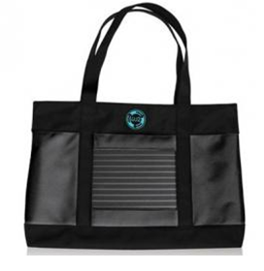
The solar cell achieves a full charge after soaking up five hours of full sunlight. The company hasn't announced pricing and availability yet.

D-Link is the first vendor to come out with a dedicated piece of hardware for the Boxee home media management software. The box is oddly shaped, but it won’t take up much space when it sits next to a TV. It streams Internet video and connects wirelessly to your computer, so it as well as a long list of supported file formats; you can play virtually any kind of video on it. The Boxee Box will be available for $199 in the second quarter of this year.
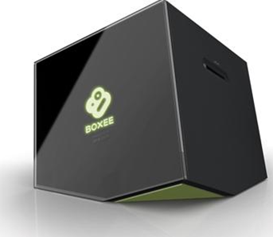

Big-Screen Skype: LG and Panasonic both announced Skype support for their connected HDTVs (equipped with Webcam accessories).

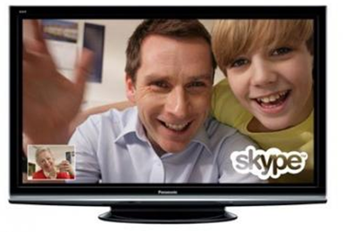

We can look forward to video chat with our loved ones in big-screen 1080p, which could mean the end of calling in underwear and PJs {:-).

Now, here is a relatively small, inexpensive item that really makes sense. Flexicord™ always the right length the award-winning Flexicord™ Single-cord solution for cables up to ten feet in length.

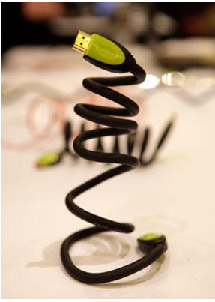

•Shipped as a compact coiled cable
•Can be extended up to 10 feet
•Holds its shape without recoiling
•Full-size Flexicord™ cables include simple re-coiling tool
•2009 CES Innovations Award Honoree*
•Available in HDMI, USB, S-Video, Network, Composite
•Introducing the Flexicord mini™!
And on that note, I will leave you to ponder this new electronic stuff. Have fun and be careful as usual on the 'net.

Aloha, Lou

